Enhance & strengthen the testing system
英語（EN）
In light of the current spread of COVID-19, Fukuoka Prefecture is once again reaching out to residents to cooperate in taking full-fledged measures to prevent the further spread of COVID-19 and to protect the medical care system.

Recently, the number of people going to hospital for exams is increasing significantly. According, even if an individual goes to the hospital, there is a long wait before they can be examined. This is resulting in a situation where children, seniors, individuals with underlying diseases and other people at a high risk of becoming seriously ill are unable to undergo an exam or testing.
To avoid these types of hospital constraints, Fukuoka Prefecture aims to secure exam/testing opportunities for both individuals at a high-risk of becoming seriously ill and those with a low-risk of becoming seriously ill, which includes young people that do not have underlying diseases.
Reflecting these perspectives, Fukuoka Prefecture is working with the central government of Japan to newly implement the following measures.

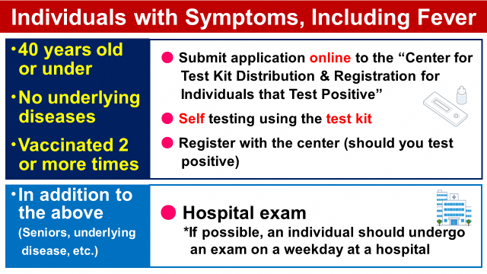
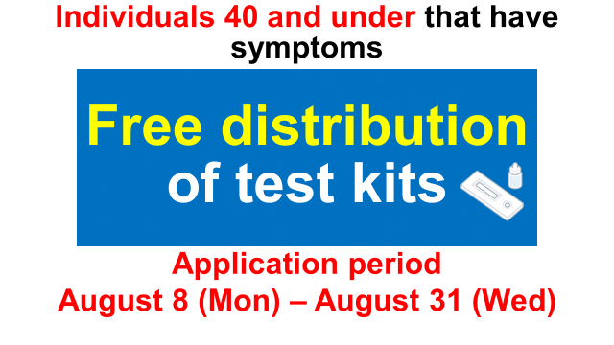

1. Eligible individuals
Fukuoka Prefecture is newly establishing a system where individuals with a low risk of becoming seriously ill, who are 40 years old or younger and who have no underlying diseases, and show symptoms, including fever, can perform a test by themselves. This measure aims to alleviate constraints faced by hospitals.

Eligible individuals:
- Residents of Fukuoka Prefecture (including individuals on a long-term stay)
- People 40 years old or younger (but excludes children that are in the third grade or younger)
- Must have no risk factors(*1), including underlying diseases
- People who have been vaccinated more than two times
Eligible individuals must meet all the criteria above and show symptoms, including fever.

*1 Malignant tumor, chronic respiratory disease, chronic kidney disease, diabetes, hypertension, dyslipidemia, cardiovascular disease, cerebrovascular disease, obesity (BMI: 30-plus), smokers, immunodeficiency following organ transplant, third trimester of pregnancy (period after the 28th week and 0 days), individuals using immunosuppressants/regulators, those with HIV

2. Flow of testing procedures
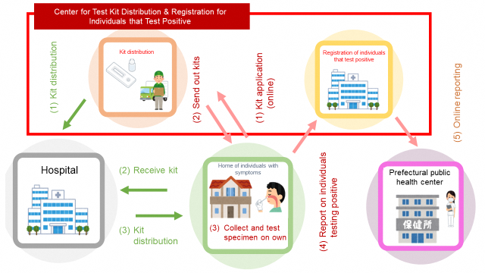

Detailed flow of procedures:
1 Fukuoka Prefecture will newly set up the “Center for Test Kit Distribution & Registration for Individuals that Test Positive.”
2 Individuals that meet the set criteria will apply for testing online.
3 A test kit will be delivered to the individual’s home in about two days from the time an application was submitted.
4 The individual that receives the kit shall collect and test the specimen on their own.
5 Should the test show the individual is positive for COVID-19, the individual should follow the instructions on the leaflet enclosed in the kit and register with the center online.
6 Doctors are stationed at the center and will confirm the symptoms, mainly via an online medical consultation.
7 Following this, the individual is to recuperate at their home in compliance with instructions by the public health center.

3. Test kit application and registration by individuals that tested positive for COVID-19
(1) Test kit application
In principle, people desiring the delivery of a kit should submit an application online.
The application period is from August 8 to August 31.
Read the two-dimensional bar code to access the application site.
*A single individual can only submit one application. (One kit is distributed per application)
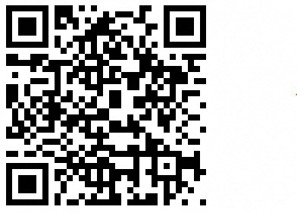
(2) Registration by individuals testing positive for COVID-19
The period for registration is from August 8 to September 7, 2022.
Confirm the details in the leaflet enclosed in the test kit and access the registration site.

4. Inquiries

Inquiry content | Telephone no. | Hours of operation | Language support
Inquiries related to test kit application | 050-2018-7587 | 9:00 to 18:00  (Inquiries also taken on Saturday, Sunday and holidays) | Japanese only

Should consultation in a foreign language be required, contact the Fukuoka Multilingual Assistance & Information Center at the number below.

Inquiry content | Telephone no. | Hours of operation | Language support
Provides various consultations, including troubles in daily life, such as employment/labor, housing and children’s education, and residential/visa status and legal counsel | 0120-279-906  (Toll free) | 10:00 to 19:00  (Inquiries also taken on Saturday, Sunday and holidays) | 22 languages (Japanese, English, Chinese, South Korean, Vietnamese, Nepali, Indonesian, Tagalog, Portuguese, Thai, Spanish, French, German, Italian, Russian, Malay, Burmese, Cambodian, Mongolian, Sinhala, Hindu and Bengali)

Those individuals that are over 40 years of age and have an underlying disease should follow protocol set thus far and visit a hospital for testing. In this case as well, individual with mild symptoms, including a slight fever, cough, or sore throat, should go to a hospital close by on a weekday. We request that individuals with mild symptoms refrain, as best as possible, from going to the emergency at night or on holidays.

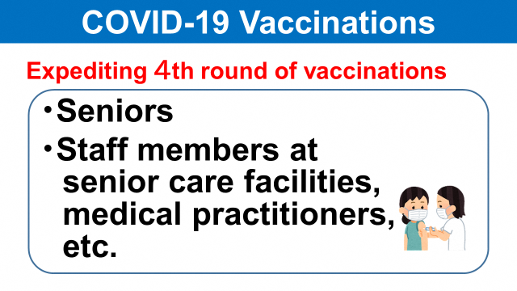

Fukuoka Prefecture is working with local municipalities to promote the administration of the fourth round of vaccinations for seniors. In addition, we encourage people working at senior care facilities and medical practitioners to quickly get their fourth vaccination.

Calling out to prefectural residents
Fukuoka Prefecture is once again asking residents in the prefecture to cooperate by thoroughly implementing basic measures to prevent the further spread of COVID-19 and to protect the medical care system

Individuals at a high-risk of becoming seriously ill, which includes seniors and people with underlying diseases, should considering being vaccinated a fourth time to protect their own life.
In addition, when going outside or meeting with people, sufficiently confirm how crowded it is where you plan to go and where COVID-19 prevention measures are in place.
Be careful and take action on your own to fully implement basic COVID-19 prevention measures. This includes wearing a mask, disinfecting your hands, avoiding the 3 Cs, and sufficient ventilation.

Individuals that regularly come in contact with individuals at a high-risk of becoming seriously ill should refrain from behavior with a high risk of infection and act cautiously.

Ahead of the upcoming Obon holiday, we anticipate an increase in opportunities to visit with seniors for the first time in a long time, mainly when individuals return to their hometown. Use the prefecture’s free test kit or other exams prior to visiting seniors, to confirm that you are negative for the COVID virus. Also, we ask that you further abide by measures to prevent the spread of infection, including wearing a mask even when at home and diligently carrying out ventilation.

We also anticipate an increase in opportunities for sharing meals with others. In the case of situations where there are many people eating together, we request that you take advantage of this type of free testing.

